Kennett High School | | 2019

Extended Learning Opportunities:
  - Handbook
Coordinator: Christine Thompson
Room B 108
356-4370 ext 3435
c_thompson@sau9.org
http://www.mwvctc.com/elo
You are about to begin an Extended Learning Opportunity (ELO). Below is a little more information about what an ELO is (and is not) and what the roles and responsibilities are for all involved. Please feel free to reach out with any other questions or concerns.
What is an Extended Learning Opportunity (ELO)?
The ELO Program at Kennett High School and Mount Washington Valley Career and Technical Center is an opportunity for students to explore and receive credit for extended learning activities outside the traditional classroom. These opportunities include, but are not limited to:
- Internships
- Work co-ops
- Job shadows
- Community service
- Independent study
- VLACs courses
- Running Start courses
- College courses
The granting of credit is based on students’ successfully demonstrating mastery of the identified competencies as approved by certified personnel. ELOs have four general components:
- Research
- Reflection
- Product
- Presentation

ELO Procedures
Step 1: Student makes an appointment with ELO Coordinator to brainstorm ideas and form learning goals
Step 2: Student fills out ELO Application and Plan. The ELO Coordinator goes over the requirements of the ELO (Research, Reflection, Product, Presentation) at this time.
Step 3: If applicable, Student, ELO Coordinator and partnering teacher meet to go over which competencies the ELO will address.
Step 4: ELO Coordinator and Student identify possible business/community partners.
Step 5: ELO Coordinator and/or student reaches out to the business. If the business isn’t pre-approved by the Department of Labor, the ELO Coordinator submits the relevant paperwork for approval.
Step 6: Student fills out and gets signatures for permissions paperwork: parent permissions, teacher recommendation, Mutual Expectations Form (see attached)
Step 7: If this is an ELO for a core class, a meeting is set up with appropriate classroom teacher
Step 8: If student will be leaving school during the school day, ELO Coordinator alerts appropriate school staff.
Step 9: The student begins the ELO
Step 10: Once all of the above steps are completed, a parking spot may be assigned if deemed necessary and upon availability.
ELO’s ARE:
- Student driven based on student interests
- Rigorous
- Career experiences in addition to the required academic classes
- Structured; students must follow specific guidelines and expectations at school and business site to obtain credit
- Available to students throughout the year
ELO’s ARE NOT:
- Intended to be an easy way for students to achieve credit
- Always held within school hours

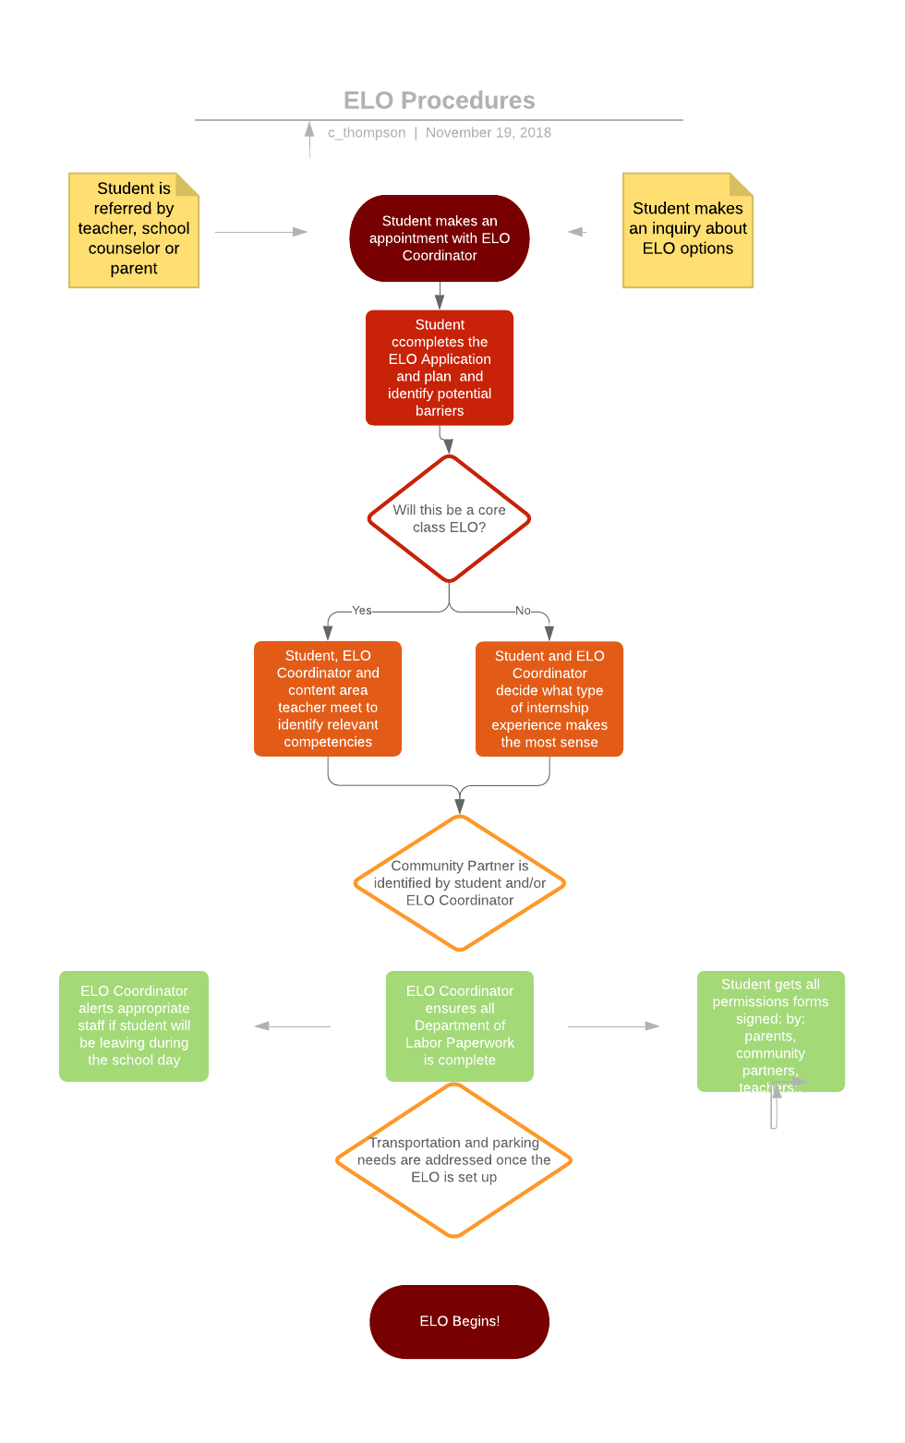

Extended Learning Opportunity Application and Plan
I understand that there will be required assignments that I will need to do before I am assigned credit for this course. They will include Research, reflection, Product and Presentation. If necessary, I will also need to show how I met certain competencies.
Signed:___________________________________________________
Student Name: | Date:
Grade Level: | Birthday
Street Address  City, State, Zip | Phone:  Email:
Would you be doing your ELO before, during, or after school?__________________
If during, what Block and day (black or white)_______________________________
Why are you pursuing this experience?
- Personal Interest
- Particular credit for graduation (i.e you need PE credit)
- Credit for full time status
- Credit for graduation
- Other:_____________________________________

Write a description of your study as a whole; explain your main focus, your guiding question(s) and your goals. Provide specific answers to the following questions:
FOCUS:
What topic or subject do you want to study?

GOALS:
What do you want to know that you don’t know now?

REASON:
Why is this study interesting and important to you?

RELEVANCE:
How will implementing this study help you reach your long term goals?

What are your strengths and weaknesses?

Methods: Describe how you will go about accomplishing the goals of your study and demonstrate proof of your learning by answering the following:
What resources do you plan to use? Include people, experiences, research materials, equipment, software etc.
How will you demonstrate your learning? What tangible evidence will you submit?
Timetable: How do you plan to structure your study?
Beginning and Ending Dates
Weekly work schedule

List your extracurricular activities below: | Time Commitment of Extracurricular activities
Due dates:
Research
Reflections
Product
Presentation

Evaluation
What criteria will you use to evaluate the success of your study? How will you know when you’ve met your goals?

Meeting Standards: What academic discipline does your study address? Which frameworks competencies will you meet?

Reflection Activities
The reflective journal is an important part of your ELO. Make sure this journal clearly details your ELO activities. You also need to clearly show what you’ve learned. Due twice throughout your ELO-due dates to be determined based on your personal ELO. Reflection activities may include any or a combination of the following: journals, reading responses, blogs etc.
When you journal write down the following:
Date:
Activity (Action)-what you did; where you went; why you went there
Reflection (thought)- This is where you process what you got out of the activity. Include:
- What you learned
- How the activity connects with your goals/competencies
- What you liked or didn’t like
- What was easy, what was difficult
- If the activity changed the direction of your study
- What your next steps will be as a result

Extended Learning Opportunity (ELO) Reflection Journal Rubric
Extended Learning Opportunities – Reflection Rubric
 | Exemplary | Proficient | Progressing | Beginning
Connection to competencies | The student communicates about and analyzes the connections between experiences and targeted competencies and predicts future behaviors/decisions based on his/her analysis (“Next time..”) | The student communicates about and analyzes the connections between specific experiences and targeted competencies. | The student communicates about experiences and makes a connection to targeted competencies. | The student communicates about experiences; however, connections to targeted competencies are not made.
Content | The student provides thoughtful and informative reflection, giving a clear sense of what they are experiencing. | The student provides a thoughtful entry, giving a basic sense of what they are experiencing | The student provides a basic entry, but it’s unclear what is being experienced. | The entry lacks depth and is uninformative
Demonstration of Learning | The student analyzes his/her own growth by making connections between personal ideas and his/her learning experiences, leading them to new perspectives or insights. | The student analyzes his/her own growth by making connections between personal ideas and his/her learning experiences. | The student makes connections between a personal idea and an experience to establish the basis of a reflection. | The student summarizes personal experiences.
Mechanics | The student demonstrates control of media-appropriate language including vocabulary, syntax, and grammar within an organized structure. Few if any, errors. | The student demonstrates control of media-appropriate language including vocabulary, syntax, and grammar within an organized structure. Some errors. | The student demonstrates inconsistent control of media-appropriate language including vocabulary, syntax, and grammar.  Errors detract from communication. | The student demonstrates a lack of control over media-appropriate vocabulary, syntax, and grammar.  Errors disrupt the flow of communication.

Product
Your product is something that demonstrates the results of your learning. The creation of a product that reflects the knowledge and information absorbed by you is one of the focal points of your ELO. Your product should be of value to your mentor, fellow students, or the community at large.

In some ELOs the product will grow logically from the topic or discipline that you are exploring, such as a flyer for a fundraiser or a logo for marketing a product. In other cases you may need help to think creatively about what product would demonstrate the learning and mastery of competencies involved.

Your product does not have to summarize your learning. Below are some ideas for Products
(Adapted from Teaching for Today, from McGraw-Hill and from NH DOE CBAS 2006)

Spreadsheet Video Advertisement
Web development Visual graphic Skit
Song 3-D Model Chart
Map Illustrated Timeline and more…
Venn diagram Travel guide
Flyer Persuasive letter
Quilt Floor plan
Kit-health Diorama
Original Recipe Letter to the Editor
Menu Ted Talk
Agenda for a meeting Lesson Plan

Extended Learning Opportunities – Product Rubric
 | Exemplary | Proficient | Progressing | Beginning
Product connection to competencies | The product illustrates discovery of complexity and/or connectivity of the targeted competencies. | The product independently illustrates relevant connections to all the targeted goals and competencies. | The product demonstrates connections to the targeted goals and competencies, dependent on further explanation. | The product is completed with little, if any, evidence of the targeted goals and competencies.
Product Quality | The product meets all of the design criteria established by the mentor, school personnel and student in the plan and additionally reflects modifications made in response to authentic feedback. | The product meets all of the design criteria established by the mentor, certified school personnel, and student in the plan. | The product meets half the design criteria established by the mentor, certified school personnel, and student in the plan. | The product has little, if any, evidence of meeting the design criteria established by the mentor, certified school personnel, and student in the plan.
Use of feedback | The product has been evaluated by the mentor or certified school personnel and an authentic audience. Modifications have been made based on feedback or expert critique and/or the product has been adopted for use by the authentic user/audience. | The product has been evaluated by the mentor or certified school personnel and an authentic audience within an  Appropriate environment. Feedback has been collected. | The product has been shared with the mentor or certified school personnel and an authentic user/audience within an appropriate context. Possible source of feedback are identified. | The product has been shared with mentor or certified school personnel for evaluation.
Originality | The product reflects a fusion of student interest with the needs of the user/audience. The product is recognized by the mentor/certified school personnel as a unique and original solution to the design criteria. | The product reflects a fusion of student interest with the needs of the user/audience. The product is recognized by the mentor/certified school personnel as a unique and original solution to the design criteria. | The product shows evidence of a design based either on the needs of an authentic user/audience or the interest of the student. The product is recognized by the mentor/certified school personnel as an uncommon but successful solution to the design criteria. | The product was external to student interest and /or the needs of the user/audience. (Product is the result of an assignment.)

ELO Presentation Guide

Every ELO presentation will be different because each ELO is different. The presentation is really the story of your experience. You don’t have to educate the audience on your particular subject; it is more important to explain why you did the study, what you did during the study and what you learned from it. These are the aspects that all students should cover, below are some suggestions to help you plan and organize your presentation.

- INTRODUCTION: Explain your study (Internship): (3-5 slides)
- How did you get started (plan)
- What did you want to learn?(goals)
- Why did you want to learn it?

- BODY: Explain your activities: (10-15 slides)
- Who were the people you worked with?
- What kind of work did you do?
- What challenges you faced in completing your activity?
- What were some of the rewarding parts?

- CONCLUSION: Describe your learning (3-5 slides)
- What was easy?
- What was hard?
- What surprised you?
- Did you achieve your goals?
- What would you do differently knowing what you now know?
Grading: Your audience will be asked to rate you on the following:
Visuals: Are your photos, videos and/or graphic representations clearly connected to the work you have done? Will they help your audience understand your study/internship?
Organization: Does you present ideas in an organized way
Delivery/Audience: Does your presentation last at least 7-10 minutes but no more than 20 minutes? Do you make eye contact with the audience? Is your language appropriate to explain the subject?
Relevance: Do you show how this study/internship has importance to your life?
Knowledge: Can you show growth from this experience? How did this study bring you knowledge that you would not have had? How will you use it in the future?

Extended Learning Opportunities – Presentation Rubric
 | Exemplary | Proficient | Progressing | Beginning
Communication Strategies | The student communicates the information seamlessly through logical organization, clear focus, smooth transitions, well-chosen supporting details, and a coherent conclusion. The student’s delivery uses a variety of strategies to engage the audience and responds to audience cues. | The student communicates the information through logical organization and clear focus. The student’s delivery is appropriate to the audience, context, and purpose | The student communicates the information despite inconsistent organization and/ or delivery. | The student does not communicate intended information because of a lack of organization.
Use of supporting materials and tools | The student frequently integrates relevant supporting materials that add or clarify information for the presentation. | The student integrates relevant supporting materials that add or clarify information for the presentation. | The student infrequently references supporting materials, which may or may not add information to the presentation. | The student has materials that interfere with the presentation or are not referenced.
Ability to self-reflect | The student explains the reasons for choosing the goals of the learning experience, communicates how he/she used the learning experience to address the targeted competencies, and makes further connections to prior and future learning. | The student explains the reasons for choosing the goals of the learning experience and how he/she used the learning experience to address the targeted competencies. | The student explains the reasons for choosing the goals of the learning experience or the targeted competencies. | The student identifies the goals of the learning experience and/or the targeted competencies.
Use of Inquiry | The student presents his/her response to the essential question and explains how he/she used it to generate additional questions, extensions or cross-Curricular relationships. | The student presents his/her response to the essential question. The student describes how it guided his/her work, and whether or not the question changed. | The student states his/her essential question, but is unable to articulate how it guided their work. | The student makes no reference to the essential question.

Permission for Extended Learning Opportunities (ELO) and Work Based Learning (WBL)
Before beginning an internship, job shadow, work coop or other extended learning opportunity; the student must make an appointment with the ELO Coordinator to discuss his/her eligibility for the placement. Some students have already discussed the ELO/WBL with the business and others will need the Coordinator to make the initial contact and discuss the feasibility of whether or not the company can host a student in this capacity. The student is given a teacher Recommendation form to be filled out by a teacher of their choice from Kennett and returned to the ELO Coordinator. Once that recommendation form is turned in, the student is given a mutual agreement form. This form ensures that all parties (business, parent, themselves and the ELO Coordinator) are aware of, and in support of, the ELO/WBL experience.
BEFORE THE EXTENDED AND/OR WORK BASED LEARNING EXPERIENCE CAN BEGIN, PLEASE PROVIDE COPIES OF THE ITEMS BELOW TO THE EXTENDED LEARNING OPPORTUNITIES COORDINATOR
___Vehicle Registration
___Permission from parent for student to participate in the ELO/WBL program (below)
___Permission from parent/guardian to drive to/from school to the ELO/WBL site (page 2)
In addition to what is required from Kennett High School, some of the companies students work with will require certain forms/documentation to be filled out before a student can begin work. Parents should know that the employees of the businesses are not background checked by Kennett High School. The school carries catastrophic insurance for ELO activities; however it is recommended that host sites carry commercial liability insurance which also covers them when hosting students. Parents may already have insurance that covers work based learning activities on their policy.
The state of New Hampshire does not require motorists to have automotive insurance. The Conway School District, Kennett High School, the Mount Washington Valley Career and technical center and SAU #9 are not responsible for any damages from insured, uninsured and/or underinsured motor vehicle accidents. I give my son/daughter permission to drive to and from the work site
Part 1: Parent Permission
Parent Signature Date
I give my son/daughter permission to participate in the ELO and/or WBL program

_____________________________________________________________________________________
Parent Signature Date

Part 2: School District Permission
Permission is hereby granted for ____________________to travel in his/her own vehicle to and from his/her Extended Learning and/or Work Based Learning Host Site at___________________________,
The permission is granted solely because his/her participation in the Extended Learning and /or Work Based Learning Opportunity which makes the presence of the vehicle necessary for the student to fully benefit. Accordingly, the permission is granted only for the period of time indicated: ________________
To _________________
Date:________________ Career and Tech Director________________________________
Witness______________________________________________
Part 3: Release from Liability
In consideration of permission granted above by the Conway School District, I hereby release and discharge the Conway School District and the _____________________________________work based learning host site, their agents, employees and officers. From all claims, demands, actions, judgements, and executions which the undersigned’s heirs, executers, administrators or assigns may have, or claim to have, against the Conway School District and/or Extended and Work Based Learning host site their successors or assigned, for all personal injuries, known or unknown and injuries to property, caused by, or arising out of, the above described activity.

I understand that during the time my son/daughter/ward, _____________________________is in transit between Kennett High School and ___________________________________Extended and/or work based learning host site, he/she will be acting independently of school officials and that said officials will have no means of protecting his/her safety and well-being, I further understand that this permission is granted solely because the need for travel in private conveyance is directly related to my son/daughter/ward’s Job Shadow/Internship/Work Coop/ELO, and that it is granted for a period not to exceed 180 school days.
I further understand that no other person is permitted to travel with ________________________in the vehicle at this time and that permission will become automatically void should another person be present in the vehicle during the period for which permission is granted.
I understand, have read this release and understand all its terms. I execute it voluntarily and with full knowledge of its significance. I have executed this release on the date indicated next to my name.
Date__________ Parent/Guardian Signature_______________________________________________

Extended Learning Opportunity
Mutual Expectations Agreement
The expectations and responsibilities of those involved in the program are listed below. All involved parties will be invited to the students’ final presentation.
Parties to the Agreement
Student:_______________________________ School: Kennett High School
Parent/Guardian:____________________________Phone:___________________
ELO Coordinator: Christine Thompson Phone: 603-356-4370 Email: c_thompson@sau9.org
Partnering Organization:______________________Contact Person:__________________
Mailing Address:___________________________________________Phone______________
Email:_______________________________________________
The School ELO Coordinator will:
- Provide relevant information about the student to the community partner
- Ensure that liability for the student and school personnel (if applicable) working with the student will be assumed by the school district.
- Be the liaison responsible for communication any relevant information between the school, student and community partners.
- Help student create their ELO goals and the plan to reach those goals.
- Have partnering organization approved in accordance to the State of New Hampshire Department of Labor, prior to the student’s start date.
The student will:
- Contact the partnering organization if he/she will be out sick or is aware of upcoming dates that they aren’t available.
- Participate in any orientation or training meetings if necessary while on the site.
- Follow all rules and regulations of the partnering organization, which includes safety or training.
- Work to fulfill their goals, competencies and ELO requirements in order to complete their project
The Community Partner will:
- Ensure a safe environment for the student and adhere to all state and federal regulations with regards to employment.
- Allow students to participate in work place meetings/training when appropriate.
- Designate a Mentor who will guide the student to help him/her reach his/her goals.
- Communicate any questions or concerns to the ELO Coordinator
- Rate the student midway through the experience using the Work Ethic Rubric (attached)
Parent/Guardian will:
- Help student complete the requirements of the plan
- Support the students’ effort
- Allow student to participate in specified activities related to the ELO

Please sign below

ELO Coordinator____________________________________________________

Student____________________________________________________________

Parent______________________________________________________________

Community Partner___________________________________________________

Thank you for your support!

